**3.** Develop a Django app that displays current date and time in server

**views.py**

from django.shortcuts import render

import datetime

from django.http import HttpResponse

# Create your views here.

def cdt(request):

 dt=datetime.datetime.now()

 resp="<h1>Current Date and Time is %s<h1>"%(dt)

 return HttpResponse(resp)

**urls.py**

from django.contrib import admin

from django.urls import path

from ct1 import views

urlpatterns = [

path('admin/', admin.site.urls),

path('currentDT/',views.cdt),

]

**Steps to Run Code**

1.python -m django startproject ti

2.cd ti

3. python manage.py startapp tii

4. python manage.py runserver

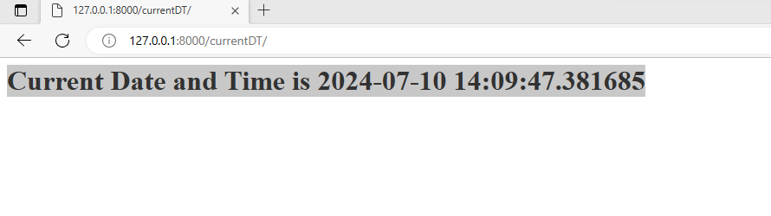

4. Develop a Django app that displays date and time four hours ahead and four hours before as an offset of current date and time in server.

i) Displays Date & Time Four hours Ahead.x

**views.py**

from django.shortcuts import render

import datetime

from django.http import HttpResponse

# Create your views here.

def aheadtime(request):

dt=datetime.datetime.now()+datetime.timedelta(hours=4)

resp="<html><head><title>Current Time Ahead by 4hrs</title></head><body><h1>Current date and Time ahead by 4 hrs is %s </h1></body></html>"%(dt)

return HttpResponse(resp)

**urls.py**

from django.contrib import admin

from django.urls import path

from tii import views

urlpatterns = [

path('admin/', admin.site.urls),

path('ahead/',views.aheadtime),

]

**Ouput:**

ii) Displays Date & Time Four hours Before.

**views.py**

from django.shortcuts import render

import datetime

from django.http import HttpResponse

# Create your views here.

def beforetime(request):

dt=datetime.datetime.now()+datetime.timedelta(hours=-4)

resp="<html><head><title>Current Time Ahead by 4hrs</title></head><body><h1>Current date and Time ahead by 4 hrs is %s </h1></body></html>"%(dt)

return HttpResponse(resp)

**urls.py**

from django.contrib import admin

from django.urls import path

from tii import views

urlpatterns = [

path('admin/', admin.site.urls),

path('before/',views.beforetime),

]

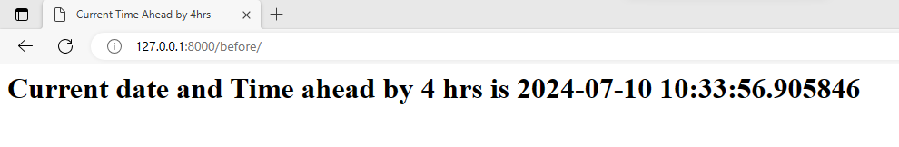

5. Develop a simple Django app that displays an unordered list of fruits and ordered list of selected students for an event

**Views.py**

from django.shortcuts import render

def fruit_student(request):

fruitList=['Mango','Kiwi','Banana','Apple','Grapes']

studentList=['Rama','Chetan','Kumar','Harish','Geetha']

return render(request,'tii/fruits_student.html',{'fruitList':fruitList,'studentList':sorted(studentList)})

**urls.py**

from django.contrib import admin

from django.urls import path

from tii import views

urlpatterns = [

path('admin/', admin.site.urls),

path('fruits/',views.fruit_student),

]

**fruits_student.html**

<!DOCTYPE html>

<html>

<head>

<style>

#a1{background-color: lightblue;color:brown}

#a2{background-color:blue;color:yellow}

</style>

<title>

Unordered Fruits and Ordered Students

</title>

</head>

<body>

<h1 id="a1">Unordered List of Fruits</h1>

<ul>

{% for fruit in fruitList %}

<li>{{fruit}}</li>

{% endfor %}

</ul>

<h1 id="a2">Ordered List of Students Selected for an Event</h1>

<ol>

{% for student in studentList %}

<li>{{student}}</li>

{% endfor %}

</ol>

</body>

</html>

**Output**

To create html file

Go to app->create folder -templates\tii

Click on tii->create html file(fruits_student.html)

**Add app in setting.py**

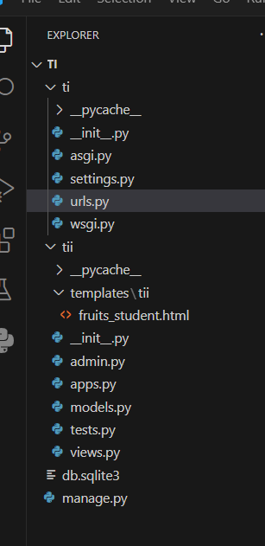

6. Develop a layout.html with a suitable header (containing navigation menu) and footer with copyright and developer information. Inherit this layout.html and create 3 additional pages: contact us, About Us and Home page of any website.

**Views.py**

from django.shortcuts import render

def home(request):

return render(request,'header1/home.html')

def contactus(request):

return render(request,'header1/contactus.html')

def aboutus(request):

return render(request,'header1/about.html')

**urls.py**

from django.contrib import admin

from django.urls import path

from header1 import views

urlpatterns = [

path('admin/', admin.site.urls),

path('',views.home),

path('contactus/',views.contactus),

path('aboutus/',views.aboutus),

path('home/',views.home),

]

**layout.html**

<!DOCTYPE html>

<html>

<head>

<style>

nav{background-color: lightblue;padding: 15px;}

</style>

<title>

{% block title %} {% endblock %}

</title>

</head>

<body>

<nav>

<a href="/home/">HOME</a>

<a href="/contactus/">CONTACT US</a>

<a href="/aboutus/">ABOUT US</a>

</nav>

<section>

{% block content %} {% endblock %}

</section>

<footer>

<hr>

&copy; Designed and Developed by Dr. Harish Kumar B T, CSE, BIT, Bangalore-04

</footer>

</body>

</html>

**home.html**

{% extends 'layout.html' %}

{% block title %} HOME Page {% endblock %}

{% block content %}

<h1>This is my home page</h1>

{% endblock %}

**about.html**

{% extends 'layout.html' %}

{% block title %} ABOUT PAGE {% endblock %}

{% block content %}

<h1>About Us</h1>

<p>Dr. Harish Kumar B T, Asso. Prof, Dept of CSE, BIT</p>

{% endblock %}

**contactus.html**

{% extends 'layout.html' %}

{% block title %} Contact us {% endblock %}

{% block content %}

<h1>Contact us</h1>

<p>Name: Dr. Harish Kumar B T</p>

<p>Designation:Asso. Prof </p>

<p>Mobile: 9980119894</p>

<p>Email: harish.bitcse82@gmail.com</p>

{% endblock %}

**Make these changes in Setting.py**

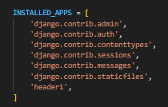

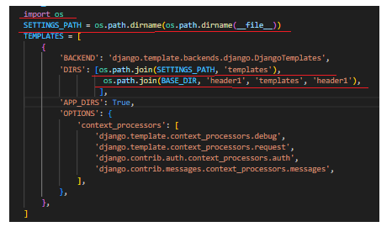

**

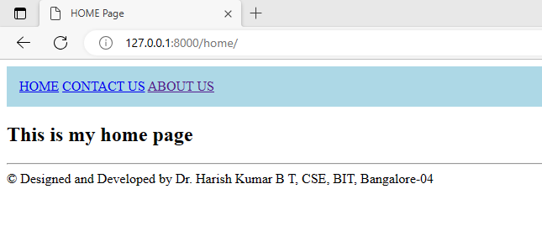

7. Develop a Django app that performs student registration to a course. It should also display list of students registered for any selected course. Create students and course as models with enrolment as ManyToMany field.

**basicTemplate.html**

<!DOCTYPE html>

<html>

<head>

<style>

nav{background-color: lightblue;padding: 15px; }

nav a {

color: #fff; /* Text color */

text-decoration: none; /* Remove underline */

padding: 10px 20px; /* Padding around each link */

margin: 0px 10px; /* Spacing between links */

border-radius: 5px; /* Rounded corners */

background-color: #555;

flex-wrap: wrap;

}

nav a:hover {

background-color:aqua;/* Background color on hover */

}

ul {

list-style: none;

margin: 0;

padding: 0;

display: flex; /* Use flexbox */

flex-wrap: wrap; /* Allow items to wrap to the next line */

flex-direction: row; /* Display items in a column */

}

li {

margin-right: 20px;

margin-bottom: 25px;

}

</style>

<title>

{% block title %} {% endblock %}

</title>

</head>

<body>

<center> <h1 style="background-color: blue;color:yellow"> STUDENT COURSE REGISTRATION PORTAL</h1></center>

<nav>

<ul>

<li> <a href="/home/">HOME</a></li>

<li> <a href="/studentlist/">STUDENT LIST</a></li>

<li> <a href="/courselist/">COURSE LIST</a> </li>

<li> <a href="/register/">REGISTER</a></li>

<li> <a href="/enrolledlist/">ENROLLED LIST</a></li>

<li> <a href="/addproject/">ADD PROJECT</a></li>

<li><a href="/genericlistviewstudent/">GENERIC STUDENT LIST VIEW</a></li>

<li> <a href="/download_course_table_as_csv/">DOWNLOAD COURSE AS CSV</a> </li>

<li> <a href="/download_course_table_as_pdf/">DWONLOAD COURSE AS PDF</a></li>

</ul>

</nav>

<section>

{% block content %} {% endblock %}

</section>

<footer>

<hr/>

<center>

&copy; Designed and Developeb by Dr. Harish Kumar B T, Dept. of CSE, BIT, Bangalore-04

</center>

</footer>

</body>

</html>

**home.html**

{% extends 'basicTemplate.html' %}

{% block title %} Home Page {% endblock %}

{% block content %}

<li>Click on Student List to get the List of students</li>

<li> Click on Course List to get the list of courses</li>

<li>click on register to enroll student to a course</li>

{% endblock %}

**studentlist.html**

{% extends 'basicTemplate.html' %}

{% block title %} Student List {% endblock %}

{% block content%}

<h1>Student List</h1>

<table border="1">

<tr>

<th>

USN

</th>

<th>

NAME

</th>

<th>

SEM

</th>

</tr>

{% for s in student_list %}

<tr>

<td>{{s.usn}}</td>

<td>{{s.name}}</td>

<td>{{s.sem}}</td>

</tr>

{% endfor %}

</table>

{% endblock %}

**courselist.html**

{% extends 'basicTemplate.html' %}

{% block title %} Course List {% endblock %}

{% block content%}

<h1> Course List</h1>

<table border="1">

<tr>

<th>

Sub Code

</th>

<th>

Sub Name

</th>

<th>

Credits

</th>

</tr>

{% for c in course_list %}

<tr>

<td>{{c.courseCode}}</td>

<td>{{c.courseName}}</td>

<td>{{c.courseCredits}}</td>

</tr>

{% endfor %}

</table>

{% endblock %}

**enrolledlist.html**

{% extends 'basicTemplate.html' %}

{% block title %} Course Registration Details {% endblock %}

{% block content %}

<form method="POST" action="">

{% csrf_token %}

Select Course:

<select name="course">

{% for c in Course_List %}

<option value="{{c.id}}">{{c.courseCode}}</option>

{% endfor %}

</select>

<input type="submit" value="Search"/>

{% if student_list %}

<h1> List of Students registered of the course {{course.courseCode}}</h1>

<table border="1">

<tr>

<th>

USN

</th>

<th>

NAME

</th>

<th>

SEM

</th>

</tr>

{% for s in student_list %}

<tr>

<td>{{s.usn}}</td>

<td>{{s.name}}</td>

<td>{{s.sem}}</td>

</tr>

{% endfor %}

</table>

{% endif %}

</form>

{% endblock %}

**register.html**

{% extends 'basicTemplate.html' %}

{% block title %} Course Register Page {% endblock %}

{% block content %}

<h1> Student Course Registration</h1>

<form method="POST" action="">

{% csrf_token %}

Select USN:

<select name="student">

{% for s in student_list %}

<option value="{{s.id}}">{{s.usn}}</option>

{% endfor %}

</select>

Select Course:

<select name="course">

{% for c in course_list %}

<option value="{{c.id}}">{{c.courseCode}}</option>

{% endfor %}

</select>

<input type="submit" value="ENROLL"/>

</form>

{% endblock %}

**models.py**

from django.db import models

from django.forms import ModelForm

# Create your models here.

class course(models.Model):

courseCode=models.CharField(max_length=10)

courseName=models.CharField(max_length=50)

courseCredits=models.IntegerField()

def __str__(self):

return self.courseCode+" "+self.courseName+" "+str(self.courseCredits)

class student(models.Model):

usn=models.CharField(max_length=10)

name=models.CharField(max_length=40)

sem=models.IntegerField()

courses=models.ManyToManyField(course,related_name='student_set')

def __str__(self):

return self.usn+" "+self.name+" "+str(self.sem)

**views.py**

from django.http import HttpResponse

from django.shortcuts import render

from p7.models import student,course

# Create your views here.

def home(request):

return render(request,'home.html')

def studentlist(request):

s=student.objects.all()

return render(request,'studentlist.html',{'student_list':s})

def courselist(request):

c=course.objects.all()

return render(request,'courselist.html',{'course_list':c})

def register(request):

if request.method=="POST":

sid=request.POST.get("student")

cid=request.POST.get("course")

studentobj=student.objects.get(id=sid)

courseobj=course.objects.get(id=cid)

res=studentobj.courses.filter(id=cid)

if res:

resp="<h1>Student with usn %s has already enrolled for the %s<h1>"%(studentobj.usn,courseobj.courseCode)

return HttpResponse(resp)

studentobj.courses.add(courseobj)

resp="<h1>student with usn %s successfully enrolled for the course with sub code %s</h1>"%(studentobj.usn,courseobj.courseCode)

return HttpResponse(resp)

else:

studentlist=student.objects.all()

courselist=course.objects.all()

return render(request,'register.html',{'student_list':studentlist,'course_list':courselist})

def enrolledStudents(request):

if request.method=="POST":

cid=request.POST.get("course")

courseobj=course.objects.get(id=cid)

studentlistobj=courseobj.student_set.all()

return render(request,'enrolledlist.html',{'course':courseobj,'student_list':studentlistobj})

else:

courselist=course.objects.all()

return render(request,'enrolledlist.html',{'Course_List':courselist})

**urls.py**

from django.contrib import admin

from django.urls import path

from p7.views import home, studentlist,courselist,register,enrolledStudents

urlpatterns = [

path('secretadmin/', admin.site.urls),

path('',home),

path('home/',home),

path('studentlist/',studentlist),

path('courselist/',courselist),

path('register/',register),

path('enrolledlist/',enrolledStudents),

]

**OUTPUT:**

1. **Follow the same setting procedure mentioned in Program no. 6**
2. **python manage.py makemigrations**
3. **python manage.py migrate**
4. python manage.py shell

**(InteractiveConsole)**

>>>from p7.models import student,course

>>>s1=student(usn= '1BI21CS001',name= 'Harish', sem=6)

>>> s2=student(usn= '1BI21CS002',name= 'Balu', sem=6)

>>> s3=student(usn= '1BI21CS003',name= 'Channu', sem=6)

>>> s4=student(usn= '1BI21CS004',name= 'Datta', sem=6)

>>>studList=[s1,s2,s3,s4]

>>>for stud in studList:

... stud.save()

...

>>>c1=course(courseCode='21CS61',courseName='SE',courseCredits=3)

>>> c2=course(courseCode='21CS62',courseName='FSD',courseCredits=3)

>>> c3=course(courseCode='21CS63',courseName='ML',courseCredits=3)

>>> c5=course(courseCode='21CSL62',courseName='FSD Lab',courseCredits=2)

>>> courseList=[c1,c2,c3,c5]

>>> for course in courseList:

... course.save()

1. **python manage.py runserver**

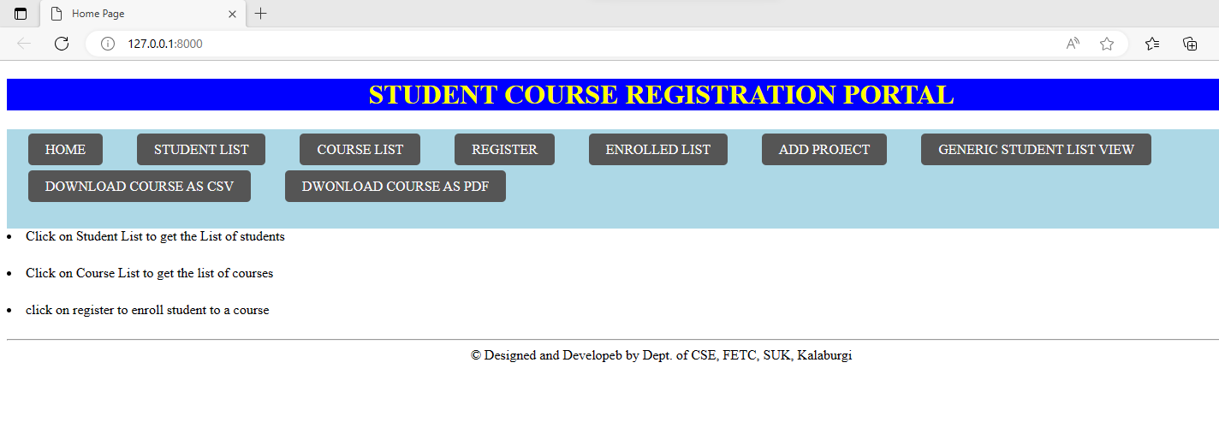

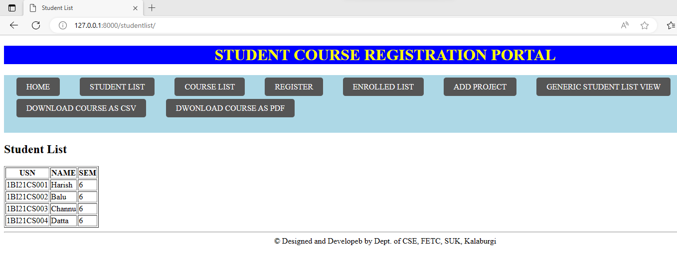

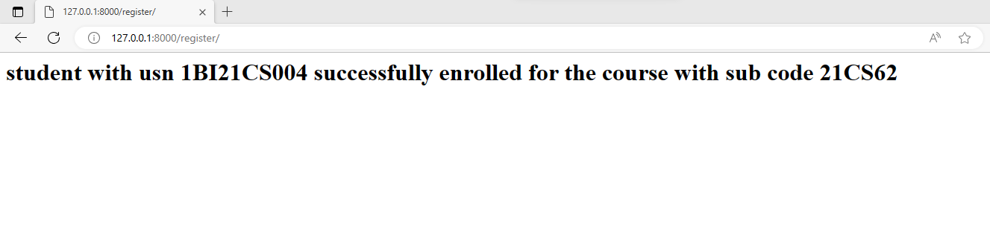

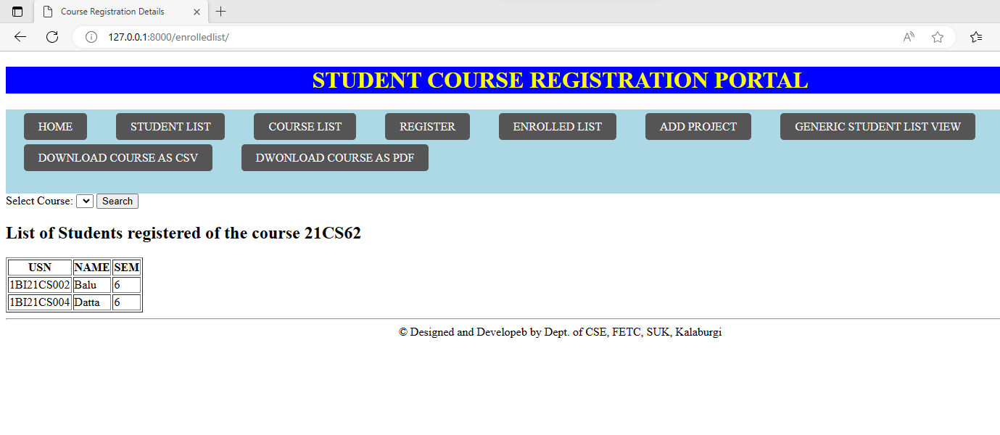

**8.** For student and course models created in Lab experiment for Module2, register admin interfaces, perform migrations and illustrate data entry through admin forms.

**basicTemplate.html**

<!DOCTYPE html>

<html>

<head>

<style>

nav{background-color: lightblue;padding: 15px; }

nav a {

color: #fff; /* Text color */

text-decoration: none; /* Remove underline */

padding: 10px 20px; /* Padding around each link */

margin: 0px 10px; /* Spacing between links */

border-radius: 5px; /* Rounded corners */

background-color: #555;

flex-wrap: wrap;

}

nav a:hover {

background-color:aqua;/* Background color on hover */

}

ul {

list-style: none;

margin: 0;

padding: 0;

display: flex; /* Use flexbox */

flex-wrap: wrap; /* Allow items to wrap to the next line */

flex-direction: row; /* Display items in a column */

}

li {

margin-right: 20px;

margin-bottom: 25px;

}

</style>

<title>

{% block title %} {% endblock %}

</title>

</head>

<body>

<center> <h1 style="background-color: blue;color:yellow"> STUDENT COURSE REGISTRATION PORTAL</h1></center>

<nav>

<ul>

<li> <a href="/home/">HOME</a></li>

<li> <a href="/studentlist/">STUDENT LIST</a></li>

<li> <a href="/courselist/">COURSE LIST</a> </li>

<li> <a href="/register/">REGISTER</a></li>

<li> <a href="/enrolledlist/">ENROLLED LIST</a></li>

<li> <a href="/addproject/">ADD PROJECT</a></li>

<li><a href="/genericlistviewstudent/">GENERIC STUDENT LIST VIEW</a></li>

<li> <a href="/download_course_table_as_csv/">DOWNLOAD COURSE AS CSV</a> </li>

<li> <a href="/download_course_table_as_pdf/">DWONLOAD COURSE AS PDF</a></li>

</ul>

</nav>

<section>

{% block content %} {% endblock %}

</section>

<footer>

<hr/>

<center>

&copy; Designed and Developeb by Dr. Harish Kumar B T, Dept. of CSE, BIT, Bangalore-04

</center>

</footer>

</body>

</html>

**home.html**

{% extends 'basicTemplate.html' %}

{% block title %} Home Page {% endblock %}

{% block content %}

<li>Click on Student List to get the List of students</li>

<li> Click on Course List to get the list of courses</li>

<li>click on register to enroll student to a course</li>

{% endblock %}

**studentlist.html**

{% extends 'basicTemplate.html' %}

{% block title %} Student List {% endblock %}

{% block content%}

<h1>Student List</h1>

<table border="1">

<tr>

<th>

USN

</th>

<th>

NAME

</th>

<th>

SEM

</th>

</tr>

{% for s in student_list %}

<tr>

<td>{{s.usn}}</td>

<td>{{s.name}}</td>

<td>{{s.sem}}</td>

</tr>

{% endfor %}

</table>

{% endblock %}

**courselist.html**

{% extends 'basicTemplate.html' %}

{% block title %} Course List {% endblock %}

{% block content%}

<h1> Course List</h1>

<table border="1">

<tr>

<th>

Sub Code

</th>

<th>

Sub Name

</th>

<th>

Credits

</th>

</tr>

{% for c in course_list %}

<tr>

<td>{{c.courseCode}}</td>

<td>{{c.courseName}}</td>

<td>{{c.courseCredits}}</td>

</tr>

{% endfor %}

</table>

{% endblock %}

**enrolledlist.html**

{% extends 'basicTemplate.html' %}

{% block title %} Course Registration Details {% endblock %}

{% block content %}

<form method="POST" action="">

{% csrf_token %}

Select Course:

<select name="course">

{% for c in Course_List %}

<option value="{{c.id}}">{{c.courseCode}}</option>

{% endfor %}

</select>

<input type="submit" value="Search"/>

{% if student_list %}

<h1> List of Students registered of the course {{course.courseCode}}</h1>

<table border="1">

<tr>

<th>

USN

</th>

<th>

NAME

</th>

<th>

SEM

</th>

</tr>

{% for s in student_list %}

<tr>

<td>{{s.usn}}</td>

<td>{{s.name}}</td>

<td>{{s.sem}}</td>

</tr>

{% endfor %}

</table>

{% endif %}

</form>

{% endblock %}

**register.html**

{% extends 'basicTemplate.html' %}

{% block title %} Course Register Page {% endblock %}

{% block content %}

<h1> Student Course Registration</h1>

<form method="POST" action="">

{% csrf_token %}

Select USN:

<select name="student">

{% for s in student_list %}

<option value="{{s.id}}">{{s.usn}}</option>

{% endfor %}

</select>

Select Course:

<select name="course">

{% for c in course_list %}

<option value="{{c.id}}">{{c.courseCode}}</option>

{% endfor %}

</select>

<input type="submit" value="ENROLL"/>

</form>

{% endblock %}

**projectreg.html**

{% extends 'basicTemplate.html' %}

{% block title %} Project Details Registration {% endblock %}

{% block content %}

<form method="POST" action="">

{% csrf_token %}

<table border="1">

{{ form.as_table }}

<tr>

<td>

<input type="submit" value="Add Project"/>

</td>

</tr>

</table>

</form>

{% endblock %}

**admin.py**

from django.contrib import admin

from p7.models import student,course

admin.site.site_header='FDP ON Django'

admin.site.site_title='FDP ON Django'

@admin.register(student)

class studentAdmin(admin.ModelAdmin):

list_display=('usn','name')

ordering=('usn',)

search_fields=('name',)

@admin.register(course)

class courseAdmin(admin.ModelAdmin):

list_display=('courseCode','courseName')

ordering=('courseCode',)

search_fields=('courseName',)

**models.py**

from django.db import models

from django.forms import ModelForm

# Create your models here.

class course(models.Model):

courseCode=models.CharField(max_length=10)

courseName=models.CharField(max_length=50)

courseCredits=models.IntegerField()

def __str__(self):

return self.courseCode+" "+self.courseName+" "+str(self.courseCredits)

class student(models.Model):

usn=models.CharField(max_length=10)

name=models.CharField(max_length=40)

sem=models.IntegerField()

courses=models.ManyToManyField(course,related_name='student_set')

def __str__(self):

return self.usn+" "+self.name+" "+str(self.sem)

class projectReg(models.Model):

student=models.ForeignKey(student,on_delete=models.CASCADE)

ptitle=models.CharField(max_length=30)

planguage=models.CharField(max_length=30)

pduration=models.IntegerField()

class projectForm(ModelForm):

required_css_class="required"

class Meta:

model=projectReg

fields=['student','ptitle','planguage','pduration']

**views.py**

from django.http import HttpResponse

from django.shortcuts import render

from p7.models import student,course,projectForm

# Create your views here.

def home(request):

return render(request,'home.html')

def studentlist(request):

s=student.objects.all()

return render(request,'studentlist.html',{'student_list':s})

def courselist(request):

c=course.objects.all()

return render(request,'courselist.html',{'course_list':c})

def register(request):

if request.method=="POST":

sid=request.POST.get("student")

cid=request.POST.get("course")

studentobj=student.objects.get(id=sid)

courseobj=course.objects.get(id=cid)

res=studentobj.courses.filter(id=cid)

if res:

resp="<h1>Student with usn %s has already enrolled for the %s<h1>"%(studentobj.usn,courseobj.courseCode)

return HttpResponse(resp)

studentobj.courses.add(courseobj)

resp="<h1>student with usn %s successfully enrolled for the course with sub code %s</h1>"%(studentobj.usn,courseobj.courseCode)

return HttpResponse(resp)

else:

studentlist=student.objects.all()

courselist=course.objects.all()

return render(request,'register.html',{'student_list':studentlist,'course_list':courselist})

def enrolledStudents(request):

if request.method=="POST":

cid=request.POST.get("course")

courseobj=course.objects.get(id=cid)

studentlistobj=courseobj.student_set.all()

return render(request,'enrolledlist.html',{'course':courseobj,'student_list':studentlistobj})

else:

courselist=course.objects.all()

return render(request,'enrolledlist.html',{'Course_List':courselist})

def add_project(request):

if request.method=="POST":

form=projectForm(request.POST)

if form.is_valid():

form.save()

return HttpResponse("<h1>Project Data Successfully saved</h1>")

else:

return HttpResponse("<h1>Project details not saved</h1>")

else:

form=projectForm()

return render(request, "projectReg.html",{'form':form})

**urls.py**

from django.contrib import admin

from django.urls import path

from p7.views import home, studentlist,courselist,register,enrolledStudents,add_project

urlpatterns = [

path('secretadmin/', admin.site.urls),

path('',home),

path('home/',home),

path('studentlist/',studentlist),

path('courselist/',courselist),

path('register/',register),

path('enrolledlist/',enrolledStudents),

path('addproject/',add_project),

]

**OUTPUT:**

1. **Follow the same setting procedure mentioned in Program no. 6**
2. **python manage.py makemigrations**
3. **python manage.py migrate**
4. python manage.py shell

**(InteractiveConsole)**

>>>from p7.models import student,course

>>>s1=student(usn= '1BI21CS001',name= 'Harish', sem=6)

>>> s2=student(usn= '1BI21CS002',name= 'Balu', sem=6)

>>> s3=student(usn= '1BI21CS003',name= 'Channu', sem=6)

>>> s4=student(usn= '1BI21CS004',name= 'Datta', sem=6)

>>>studList=[s1,s2,s3,s4]

>>>for stud in studList:

... stud.save()

...

>>>c1=course(courseCode='21CS61',courseName='SE',courseCredits=3)

>>> c2=course(courseCode='21CS62',courseName='FSD',courseCredits=3)

>>> c3=course(courseCode='21CS63',courseName='ML',courseCredits=3)

>>> c5=course(courseCode='21CSL62',courseName='FSD Lab',courseCredits=2)

>>> courseList=[c1,c2,c3,c5]

>>> for course in courseList:

... course.save()

1. **python manage.py runserver**

9. For students enrolment developed in Module 2, create a generic class view which displays list of students and detail view that displays student details for any selected student in the list.

**basicTemplate.html**

<!DOCTYPE html>

<html>

<head>

<style>

nav{background-color: lightblue;padding: 15px; }

nav a {

color: #fff; /* Text color */

text-decoration: none; /* Remove underline */

padding: 10px 20px; /* Padding around each link */

margin: 0px 10px; /* Spacing between links */

border-radius: 5px; /* Rounded corners */

background-color: #555;

flex-wrap: wrap;

}

nav a:hover {

background-color:aqua;/* Background color on hover */

}

ul {

list-style: none;

margin: 0;

padding: 0;

display: flex; /* Use flexbox */

flex-wrap: wrap; /* Allow items to wrap to the next line */

flex-direction: row; /* Display items in a column */

}

li {

margin-right: 20px;

margin-bottom: 25px;

}

</style>

<title>

{% block title %} {% endblock %}

</title>

</head>

<body>

<center> <h1 style="background-color: blue;color:yellow"> STUDENT COURSE REGISTRATION PORTAL</h1></center>

<nav>

<ul>

<li> <a href="/home/">HOME</a></li>

<li> <a href="/studentlist/">STUDENT LIST</a></li>

<li> <a href="/courselist/">COURSE LIST</a> </li>

<li> <a href="/register/">REGISTER</a></li>

<li> <a href="/enrolledlist/">ENROLLED LIST</a></li>

<li> <a href="/addproject/">ADD PROJECT</a></li>

<li><a href="/genericlistviewstudent/">GENERIC STUDENT LIST VIEW</a></li>

<li> <a href="/download_course_table_as_csv/">DOWNLOAD COURSE AS CSV</a> </li>

<li> <a href="/download_course_table_as_pdf/">DWONLOAD COURSE AS PDF</a></li>

</ul>

</nav>

<section>

{% block content %} {% endblock %}

</section>

<footer>

<hr/>

<center>

&copy; Designed and Developeb by Dr. Harish Kumar B T, Dept. of CSE, BIT, Bangalore-04

</center>

</footer>

</body>

</html>

**home.html**

{% extends 'basicTemplate.html' %}

{% block title %} Home Page {% endblock %}

{% block content %}

<li>Click on Student List to get the List of students</li>

<li> Click on Course List to get the list of courses</li>

<li>click on register to enroll student to a course</li>

{% endblock %}

**studentlist.html**

{% extends 'basicTemplate.html' %}

{% block title %} Student List {% endblock %}

{% block content%}

<h1>Student List</h1>

<table border="1">

<tr>

<th>

USN

</th>

<th>

NAME

</th>

<th>

SEM

</th>

</tr>

{% for s in student_list %}

<tr>

<td>{{s.usn}}</td>

<td>{{s.name}}</td>

<td>{{s.sem}}</td>

</tr>

{% endfor %}

</table>

{% endblock %}

**courselist.html**

{% extends 'basicTemplate.html' %}

{% block title %} Course List {% endblock %}

{% block content%}

<h1> Course List</h1>

<table border="1">

<tr>

<th>

Sub Code

</th>

<th>

Sub Name

</th>

<th>

Credits

</th>

</tr>

{% for c in course_list %}

<tr>

<td>{{c.courseCode}}</td>

<td>{{c.courseName}}</td>

<td>{{c.courseCredits}}</td>

</tr>

{% endfor %}

</table>

{% endblock %}

**enrolledlist.html**

{% extends 'basicTemplate.html' %}

{% block title %} Course Registration Details {% endblock %}

{% block content %}

<form method="POST" action="">

{% csrf_token %}

Select Course:

<select name="course">

{% for c in Course_List %}

<option value="{{c.id}}">{{c.courseCode}}</option>

{% endfor %}

</select>

<input type="submit" value="Search"/>

{% if student_list %}

<h1> List of Students registered of the course {{course.courseCode}}</h1>

<table border="1">

<tr>+

<th>

USN

</th>

<th>

NAME

</th>

<th>

SEM

</th>

</tr>

{% for s in student_list %}

<tr>

<td>{{s.usn}}</td>

<td>{{s.name}}</td>

<td>{{s.sem}}</td>

</tr>

{% endfor %}

</table>

{% endif %}

</form>

{% endblock %}

**register.html**

{% extends 'basicTemplate.html' %}

{% block title %} Course Register Page {% endblock %}

{% block content %}

<h1> Student Course Registration</h1>

<form method="POST" action="">

{% csrf_token %}

Select USN:

<select name="student">

{% for s in student_list %}

<option value="{{s.id}}">{{s.usn}}</option>

{% endfor %}

</select>

Select Course:

<select name="course">

{% for c in course_list %}

<option value="{{c.id}}">{{c.courseCode}}</option>

{% endfor %}

</select>

<input type="submit" value="ENROLL"/>

</form>

{% endblock %}

**projectreg.html**

{% extends 'basicTemplate.html' %}

{% block title %} Project Details Registration {% endblock %}

{% block content %}

<form method="POST" action="">

{% csrf_token %}

<table border="1">

{{ form.as_table }}

<tr>

<td>

<input type="submit" value="Add Project"/>

</td>

</tr>

</table>

</form>

{% endblock %}

**Views.py**

from django.http import HttpResponse

from django.shortcuts import render

from reg.models import student,course,projectForm

from django.views import generic

def home(request):

    return render(request,'reg/home.html')

def studentlist(request):

    s=student.objects.all()

    return render(request,'reg/studentlist.html',{'student_list':s})

def courselist(request):

    c=course.objects.all()

    return render(request,'reg/courselist.html',{'course_list':c})

def register(request):

    if request.method=="POST":

        sid=request.POST.get("student")

        cid=request.POST.get("course")

        studentobj=student.objects.get(id=sid)

        courseobj=course.objects.get(id=cid)

        res=studentobj.courses.filter(id=cid)

        if res:

            resp="<h1>Student with usn %s has already enrolled for the %s<h1>"%(studentobj.usn,courseobj.courseCode)

            return HttpResponse(resp)

        studentobj.courses.add(courseobj)

        resp="<h1>student with usn %s successfully enrolled for the course with sub code %s</h1>"%(studentobj.usn,courseobj.courseCode)

        return HttpResponse(resp)

    else:

        studentlist=student.objects.all()

        courselist=course.objects.all()

        return render(request,'reg/register.html',{'student_list':studentlist,'course_list':courselist})

def enrolledStudents(request):

    if request.method=="POST":

        cid=request.POST.get("course")

        courseobj=course.objects.get(id=cid)

        studentlistobj=courseobj.student_set.all()

        return render(request,'reg/enrolledlist.html',{'course':courseobj,'student_list':studentlistobj})

    else:

        courselist=course.objects.all()

        return render(request,'reg/enrolledlist.html',{'Course_List':courselist})

def add_project(request):

    if request.method=="POST":

        form=projectForm(request.POST)

        if form.is_valid():

            form.save()

            return HttpResponse("<h1>Project Data Successfully saved</h1>")

        else:

            return HttpResponse("<h1>Project details not saved</h1>")

    else:

        form=projectForm()

        return render(request, "projectReg.html",{'form':form})

class StudentListView(generic.ListView):

    model=student

    template_name="GenericListViewStudent.html"

class StudentDetailView(generic.DetailView):

    model=student

    template_name="GenericDetailedViewStudent.html"

**urls.py**

from django.contrib import admin # type: ignore

from django.urls import path # type: ignore

#from reg.views import home, studentlist,courselist,register,enrolledStudents

from reg.views import home,studentlist,courselist,register,enrolledStudents,add_project,StudentListView,StudentDetailView

#,generateCSV,generatePDF,registerAjax,enrolledStudentsUsingAjax

urlpatterns = [

    path('secretadmin/', admin.site.urls),

    path('',home),

    path('home/',home),

    path('studentlist/',studentlist),

    path('courselist/',courselist),

    path('register/',register),

    path('enrolledlist/',enrolledStudents),

    path('addproject/',add_project),

    path('genericlistviewstudent/',StudentListView.as_view()),

    path('genericdetailedviewstudent/<int:pk>/',StudentDetailView.as_view()),

]

**Model.py**

from django.db import models

from django.forms import ModelForm

import django.db.models.deletion

from django.db import migrations, models

# Create your models here.

class course(models.Model):

    courseCode=models.CharField(max_length=10)

    courseName=models.CharField(max_length=50)

    courseCredits=models.IntegerField()

    def __str__(self):

        return self.courseCode+" "+self.courseName+" "+str(self.courseCredits)

class student(models.Model):

    usn=models.CharField(max_length=10)

    name=models.CharField(max_length=40)

    sem=models.IntegerField()

    courses=models.ManyToManyField(course,related_name='student_set')

    def __str__(self):

        return self.usn+" "+self.name+" "+str(self.sem)

class projectReg(models.Model):

    student=models.ForeignKey(student,on_delete=models.CASCADE)

    ptitle=models.CharField(max_length=30)

    planguage=models.CharField(max_length=30)

    pduration=models.IntegerField()

class projectForm(ModelForm):

    required_css_class="required"

    class Meta:

        model=projectReg

        fields=['student','ptitle','planguage','pduration']

**OUTPUT:**

**OUTPUT:**

1. **Follow the same setting procedure mentioned in Program no. 6**
2. **python manage.py makemigrations**
3. **python manage.py migrate**
4. python manage.py shell

**(InteractiveConsole)**

>>>from p7.models import student,course

>>>s1=student(usn= '1BI21CS001',name= 'Harish', sem=6)

>>> s2=student(usn= '1BI21CS002',name= 'Balu', sem=6)

>>> s3=student(usn= '1BI21CS003',name= 'Channu', sem=6)

>>> s4=student(usn= '1BI21CS004',name= 'Datta', sem=6)

>>>studList=[s1,s2,s3,s4]

>>>for stud in studList:

... stud.save()

...

>>>c1=course(courseCode='21CS61',courseName='SE',courseCredits=3)

>>> c2=course(courseCode='21CS62',courseName='FSD',courseCredits=3)

>>> c3=course(courseCode='21CS63',courseName='ML',courseCredits=3)

>>> c5=course(courseCode='21CSL62',courseName='FSD Lab',courseCredits=2)

>>> courseList=[c1,c2,c3,c5]

>>> for course in courseList:

... course.save()

1. **python manage.py runserver**

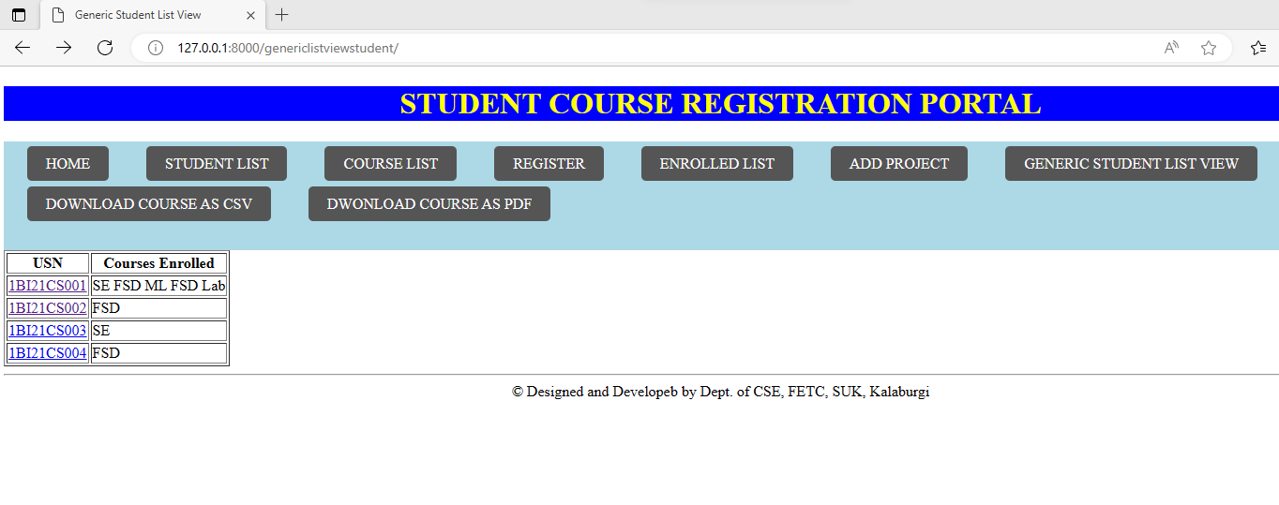

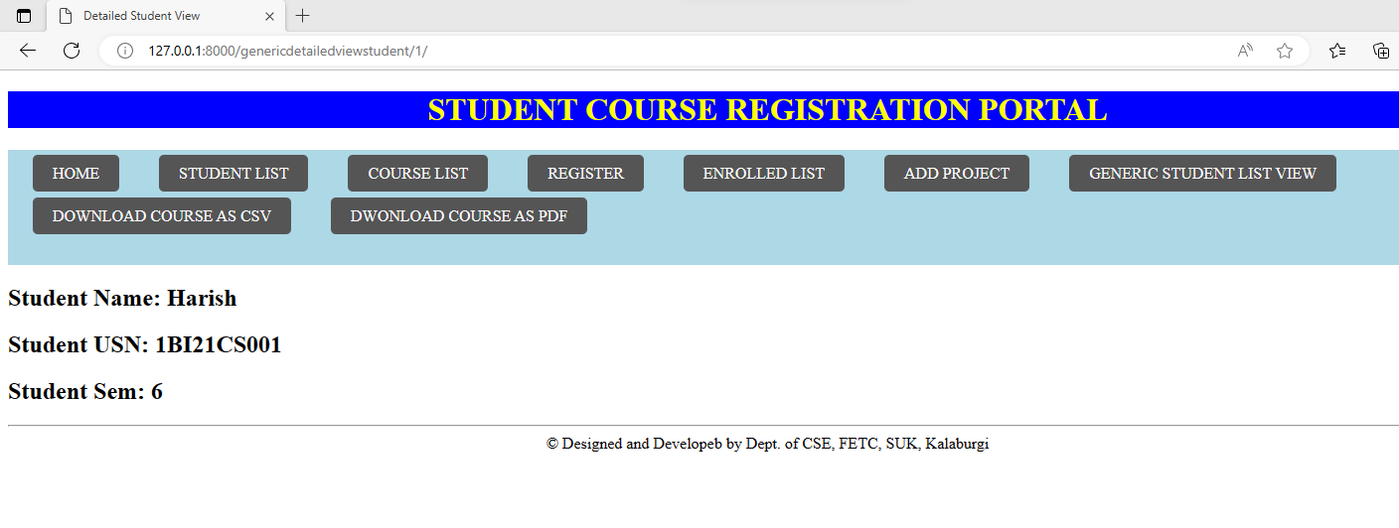

10. **Develop example Django app that performs CSV and PDF generation**

**view.py**

#csv

import csv

from django.http import HttpResponse

UNRULY_PASSENGERS = [146,184,235,200,226,251,299,273,

281,304,203, 134, 147]

def unruly_passengers_csv(request):

response = HttpResponse(content_type='text/csv')

response['Content-Disposition'] = 'attachment; filename=unruly.csv'

# Create the CSV writer using the HttpResponse as the "file."

writer = csv.writer(response)

writer.writerow(['Year', 'Unruly Airline Passengers'])

for (year, num) in zip(range(1995, 2006), UNRULY_PASSENGERS):

writer.writerow([year, num])

return response

#pdf

from reportlab.pdfgen import canvas

from django.http import HttpResponse

def hello_pdf(request):

# Create the HttpResponse object with the appropriate PDF headers.

response = HttpResponse(content_type='application/pdf')

response['Content-Disposition'] = 'attachment; filename=hello.pdf'

# Create the PDF object, using the response object as its "file."

p = canvas.Canvas(response)

# Draw things on the PDF. Here's where the PDF generation happens.

# See the ReportLab documentation for the full list of functionality.

p.drawString(100, 100, "Hello world.")

# Close the PDF object cleanly, and we're done.

p.showPage()

p.save()

return response

**urls.py**

from django.contrib import admin

from django.urls import path,include

from a1 import views

#csv

urlpatterns = [

path('admin/', admin.site.urls),

# path('',include("a1.urls")),

path('csv',views.unruly_passengers_csv),

path('pdf',views.hello_pdf),

]

OUTPUT:

**Steps to Run Code**

1.python -m django startproject ti

2.cd ti

3. python manage.py startapp tii

4. python manage.py runserver